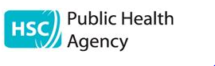

Frailty Network Autumn Conference (held on 1st October 2019)

Post Event Evaluation

Contents Page
Introduction 3
Overall Satisfaction 4
Morning Presentations 5
Afternoon workshops 6
Feedback Comments (on the day) 7
Other comments 8
The Day in Pictures 10
Summary 20

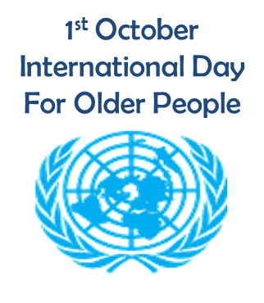

Introduction
Since the launch of the Frailty Network on 28th March 2019, this was our first conference.
The day was split into 3 parts:-
The day started with talks on the morning given by a series of both, highly qualified professionals such as Dr Roman Romero-Ortuno on the subject; Identification of Frailty, Professor Anne Hendry on Improving Outcomes through the European Frailty Prevention Approach and Claire Buchner on Technology Enabled Care and Members of Age NI such as Charity Director Paschal McKeown, Anne Murray and Miss Emily Gill. .
Masterclass sessions after lunch which were as follows:-
Session | Title | Lead
1 | Tackling the potential harms from polypharmacy for older people living with Frailty | Consultant Pharmacists
2 | Expert Age: The Outcomes that Matter to Older People | An interactive session led by Age NI Consultative Forum
3 | Improving Outcomes through Identification of Frailty | Dr Roman Romero-Ortuno

To round up the day there was a panel Q&A session and closing remarks by a member of the public Mr Robert Ferguson, who became involved in charity work in 2013.

Overall Satisfaction of the conference
Q1. Please indicate your overall satisfaction with the following aspects of the conference:
Answer Choices | Excellent | Satisfactory | Poor | Not Sure | Total
Overall structure of the conference | 49 | 14 | 0 | 0 | 63
Pre Conference Information and Registration Process | 52 | 10 | 1 | 0 | 63
Relevance of presentations | 49 | 14 | 0 | 0 | 63
Venue | 49 | 14 | 0 | 0 | 63
Opportunity to Network | 39 | 23 | 0 | 1 | 63
Hospitality (food and drink) | 33 | 28 | 2 | 0 | 63
Overall Event | 48 | 15 | 0 | 0 | 63
Are there any comments you wish to make regarding your responses above? |  |  |  |  | 16
 |  |  |  | Answered | 63
 |  |  |  | Skipped | 0

Morning Presentations

Q2. Please rate the following morning presentations:
Answer Choices | Excellent | Satisfactory | Poor | Not Sure | Total
Identification of Frailty - Dr Roman Romero-Ortuno | 57 | 5 | 0 | 0 | 62
Technology Enabled Care - Supporting people to live active , safe and healthy lives as independently as possible - Digital Health and Care Supporting People Team | 32 | 26 | 5 | 0 | 63
Improving Outcomes through the European Frailty Prevention Approach - Professor Anne Hendry | 47 | 16 | 0 | 0 | 63
Working with Older People to Identify What matters - Age NI | 44 | 19 | 0 | 0 | 63
 |  |  |  | Answered | 63
 |  |  |  | Skipped | 0

Afternoon Workshops
Q3. Please rate the following afternoon masterclass sessions:
Answer Choices | Excellent | Satisfactory | Poor | Did not attend | Total
Session 1 - Tackling the potential harms from polypharmacy - Consultant Pharmacists | 7 | 5 | 0 | 22 | 34
Session 2 - Expert Age: The Outcomes that Matter to Older People - Age NI Consultative Forum | 4 | 8 | 1 | 20 | 33
Session 3 - Improving Outcomes through Identification of Frailty - Dr Roman Romero-Ortuno | 33 | 10 | 1 | 10 | 54
 |  |  |  | Answered | 61
 |  |  |  | Skipped | 2

Feedback Comments (on the day)
Attendees were asked to write down 3 words to describe the event.

Informative, Inspiration Interesting

Inspiring, Co-Produce, Compassion
Start of a journey, Large Task ahead

Educational
Thought Provoking
Tangible

Infrastructure, Collaborative, convenient location

Other Feedback
“Excellent event and so worthwhile, lots of learning.” “Very clear and well explained.”

“Opportunity for interaction.” “Found the day very enjoyable and relevant.”

“It would be good to have a masterclass on CGA.”

“Refreshing to see a clinician who views holistically and sees the bigger picture.”

“Very clear and well explained.” “Excellent Conference.”

“Very Informative sessions, the question and answer session at the end was very beneficial.”

“I would have liked to attend all the masterclasses so perhaps some of them could be of some of them could be replicated for 2020. The conference was overall very good as I came to it with limited knowledge of the subject and how it all came about.”

“More audience engagement.” “Interesting Talks”
“I liked the opportunity of asking Dr Romero-Ortuno about frailty services to ED in Dublin and the discussions regarding CGA, lengths of stay and readmissions, sometimes people living with frailty have variable hospital longer when under different consultants. There is a focus on lengths of stay and delayed in discharge and less of a focus on hospital readmission rates of people living with frailty.”
Other responses
“Was difficult to network as most people went back to sit in large room as limited options outside of room.”
“Really refocused my attention to reversing or preventing frailty during my daily engagement with clients. Presenters were excellent.”
“The table I was on at the breakout session with AgeNI was not useful as their volunteers were not absolutley sure what way the discussion should take and I felt it was time wasted.”
“Brilliant speakers and relevance to our patient populations and challenges ahead.”
“Limited parking. Extra time needed to find suitable parking.”
“I suppose rather than balancing a cup of coffee and a sandwich on your knee, somewhere to sit down and talk with each other might have been better. Parking was a bit tricky too.”
“Networking possibly more efficient”
“Excellent event, generated lots of discussion and positivity to take forward the work going forward.”
“A wonderful gathering, thought evoking and stimulating - thank you very much for all your efforts.”
“Welcomed opportunity to hear the latest evidence around frailty from a variety of keynote speakers including patients. Would have liked to attend all the workshops but realize not possible.”
“I really enjoyed the presentations from the members of Age NI, which provided a very good insight / learning opportunities for staff working in healthcare to reflect their current service provision. I also enjoyed hearing about the delivery of frailty services in Dublin. Would probably be interested in their training programmes that are being delivered nationally.”

The Day in Pictures

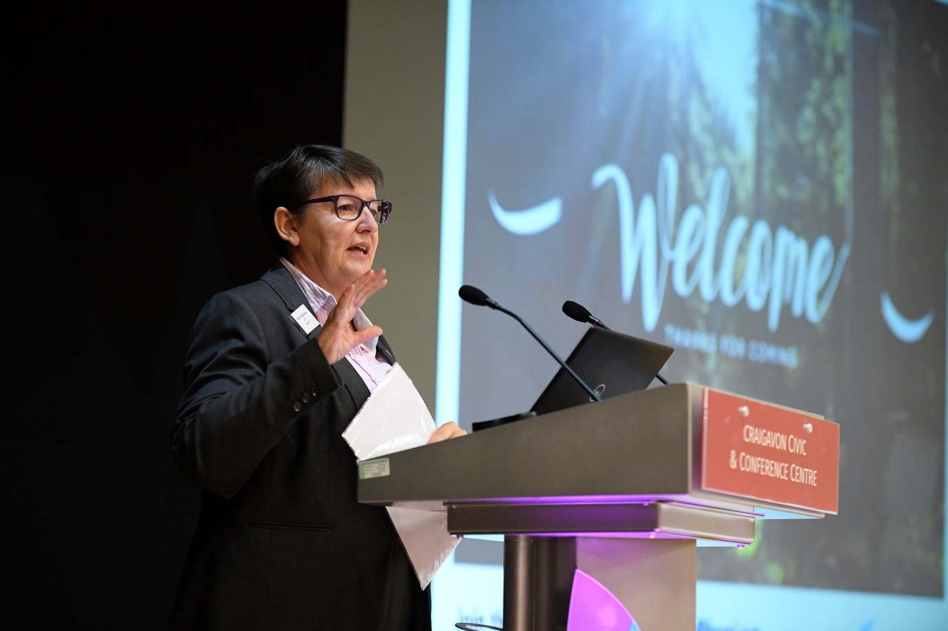
Linda Robinson, Chief Executive, Age NI
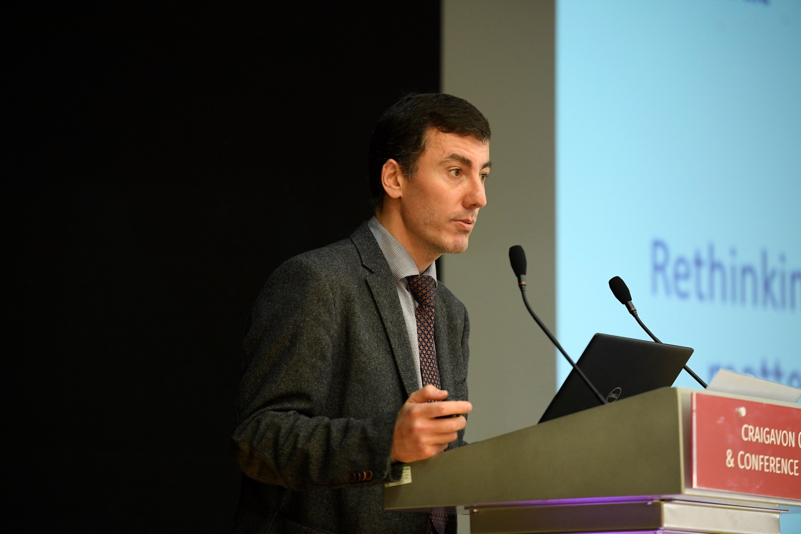
Dr Roman Romero-Ortuno
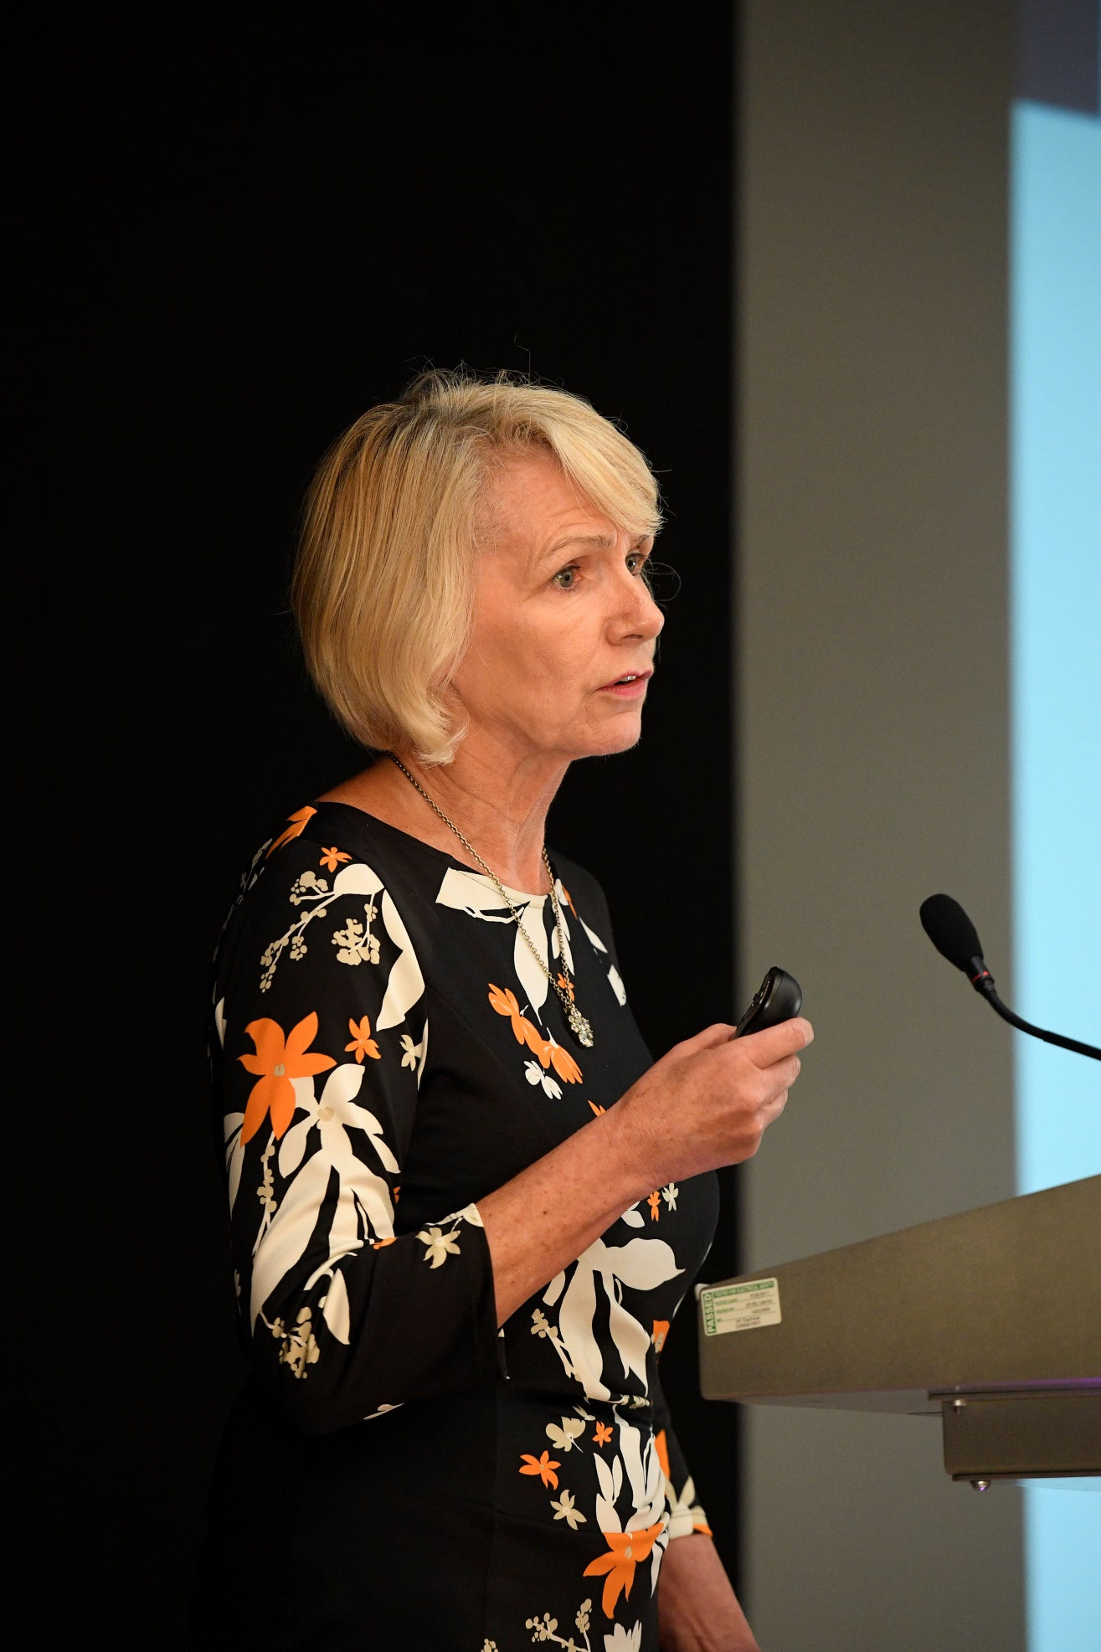
Professor Anne Hendry

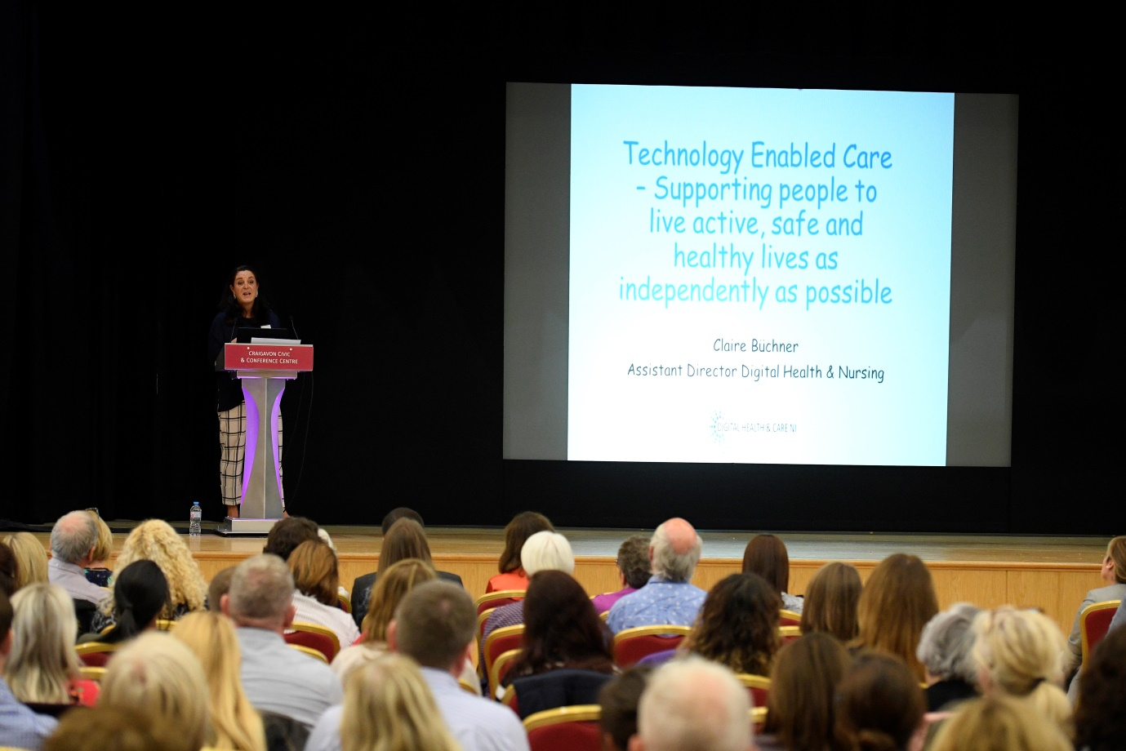
Claire Buchner, Nurse Consultant.
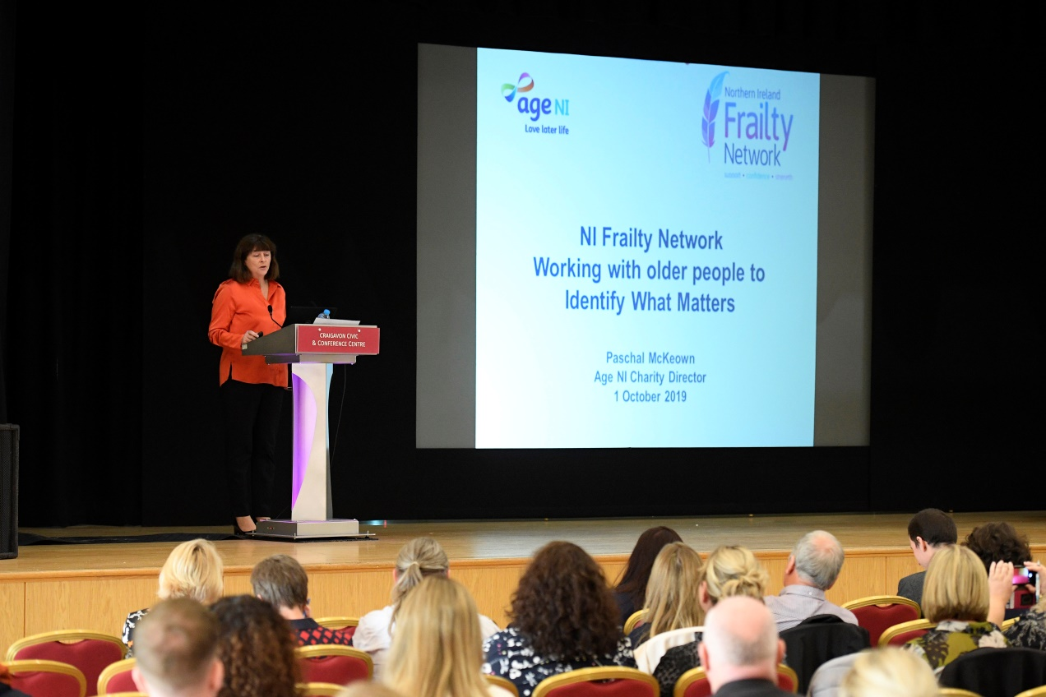
Paschal Buchner, Age NI, Charity Director
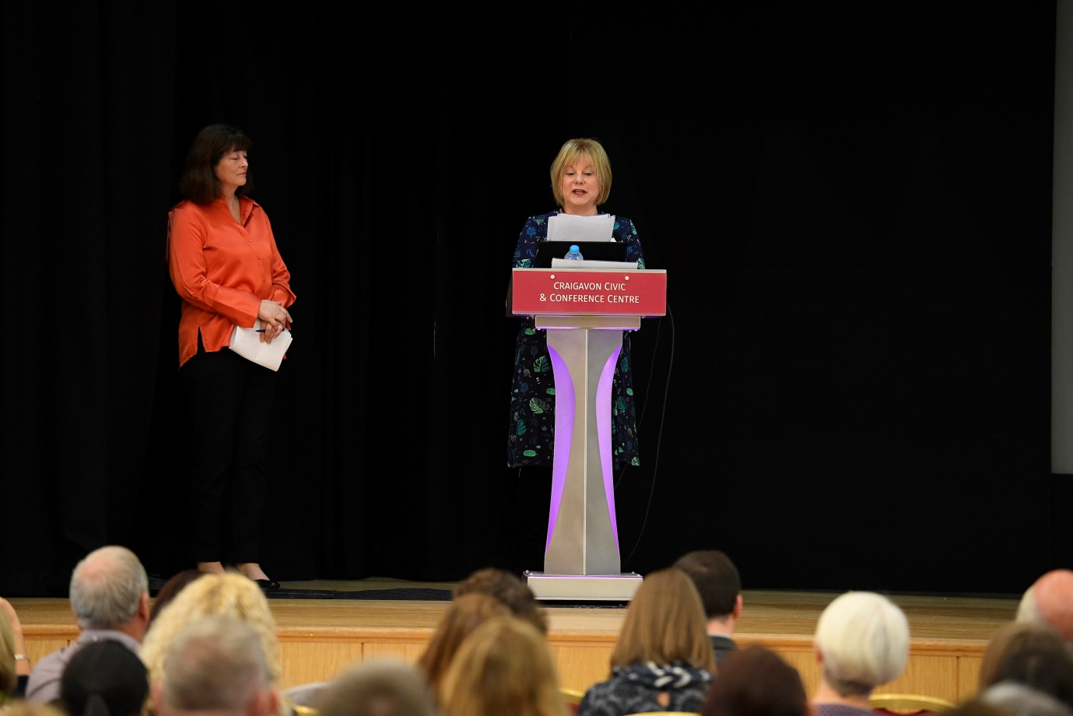
Anne Murray
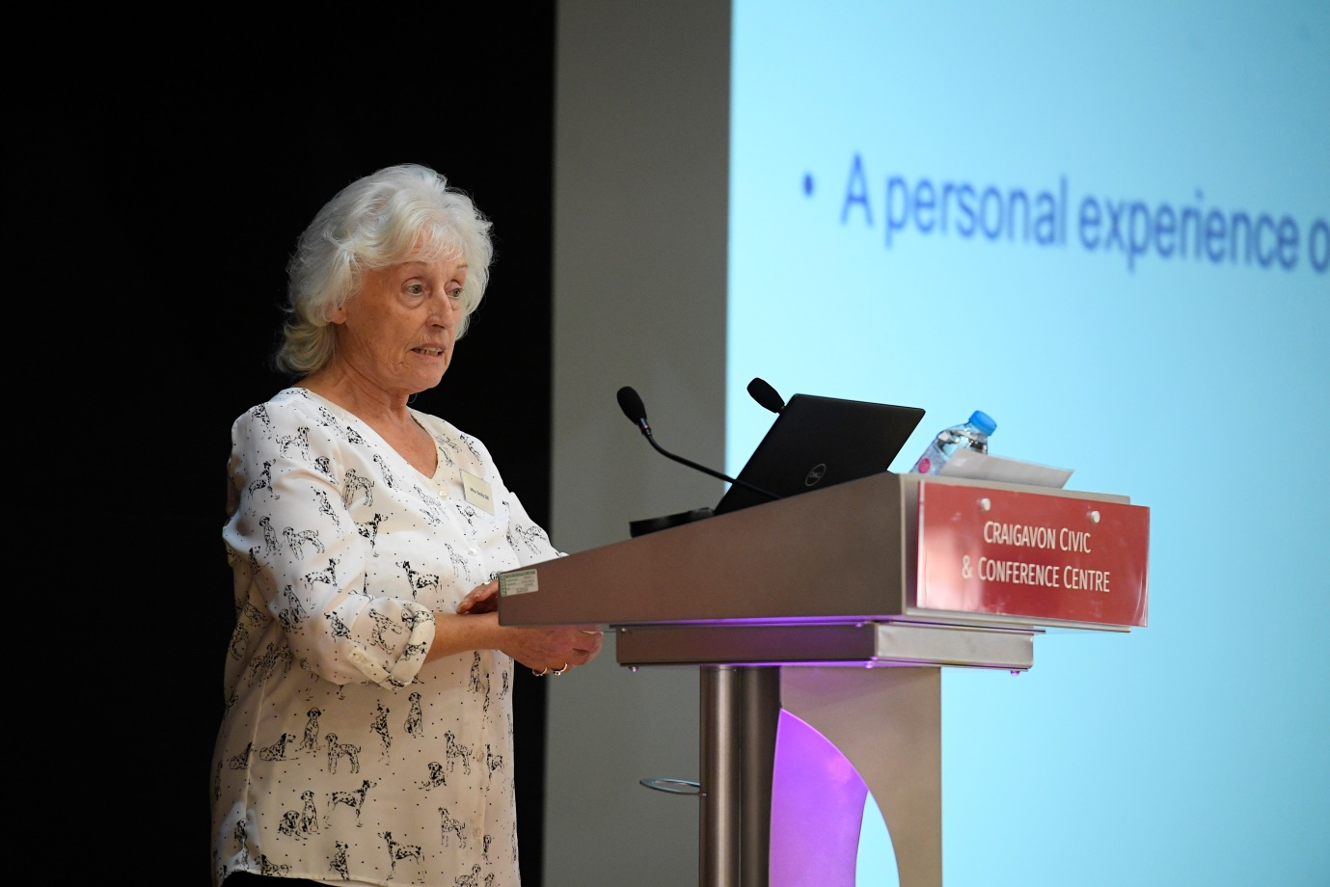
Miss Emily Gill.
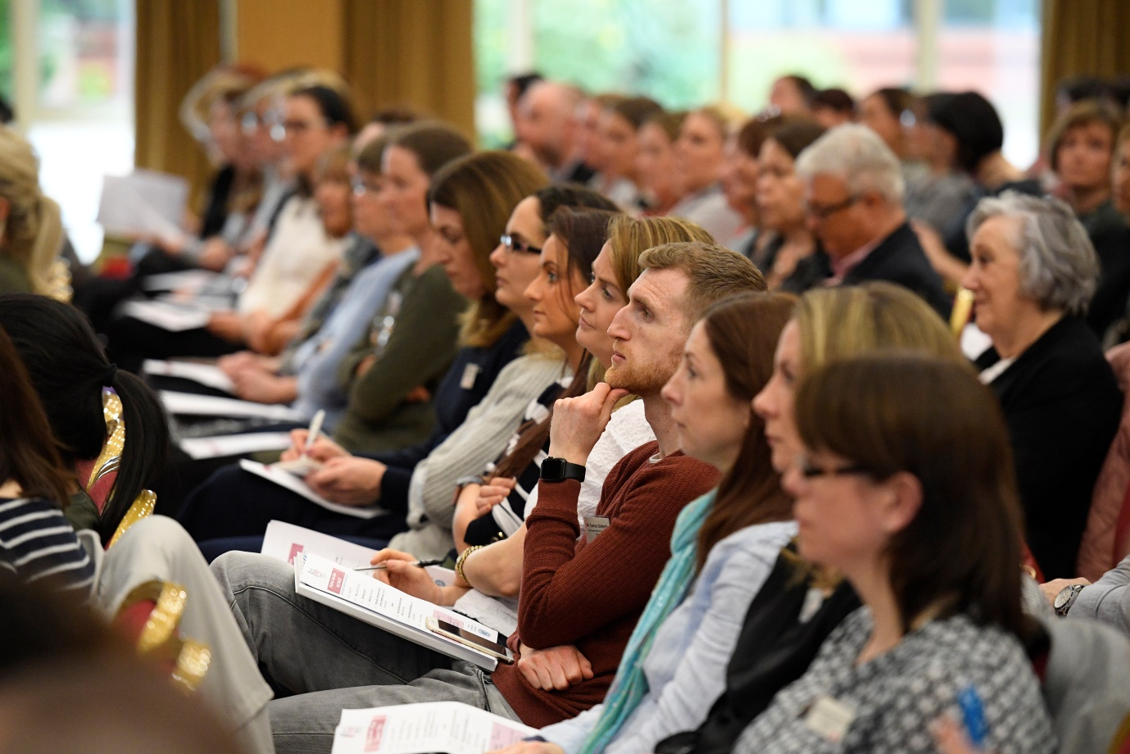
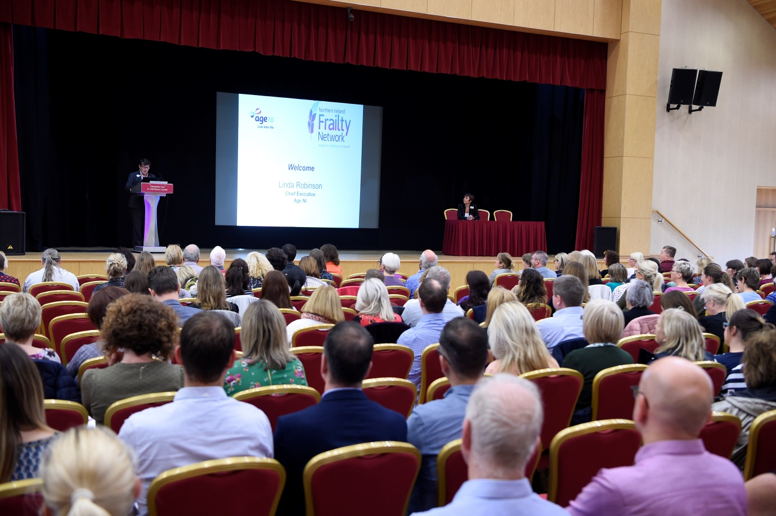
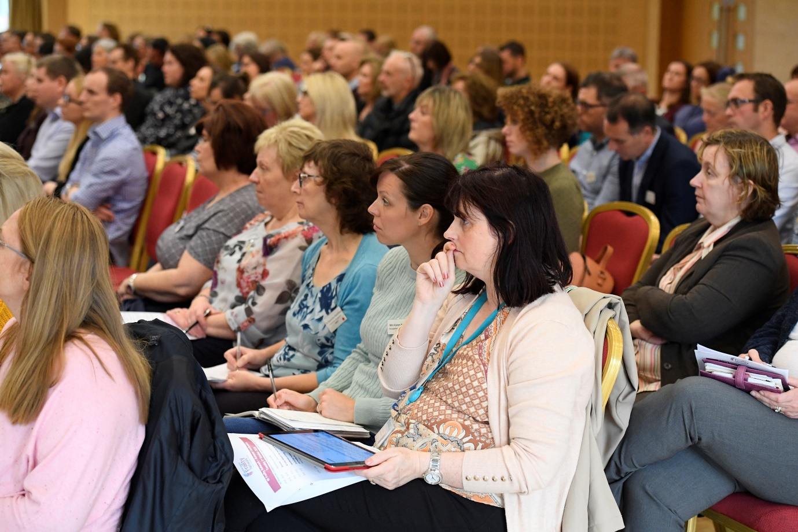
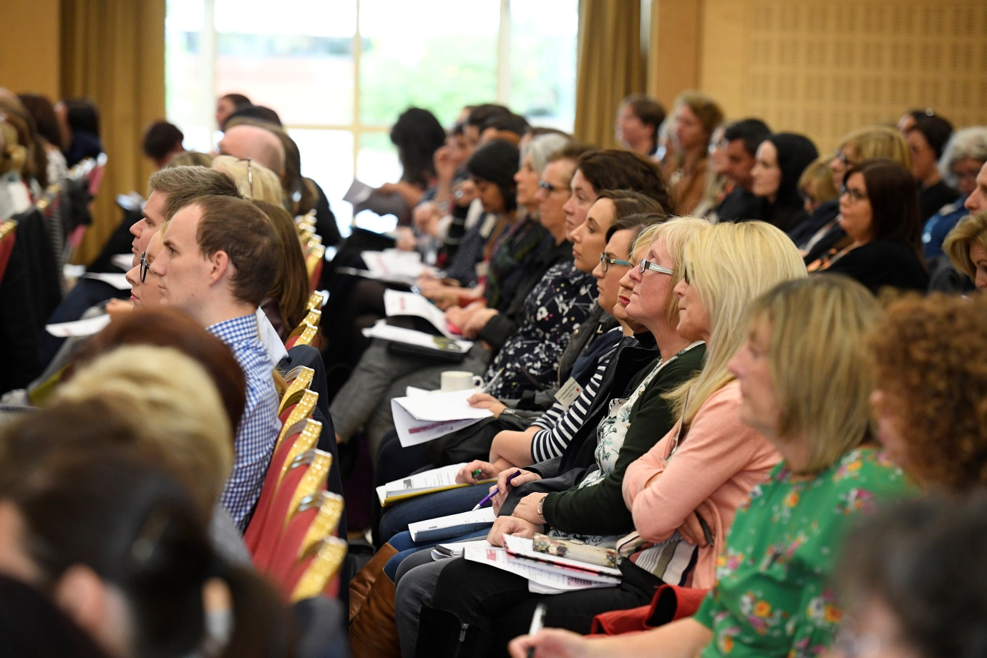
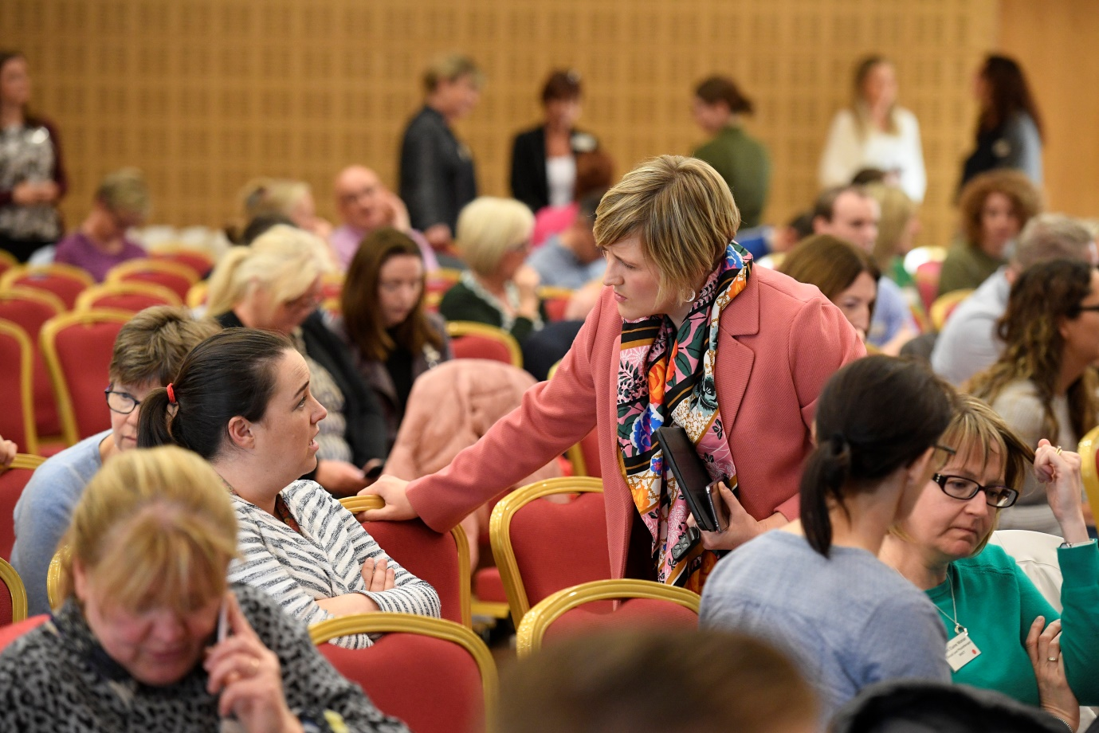
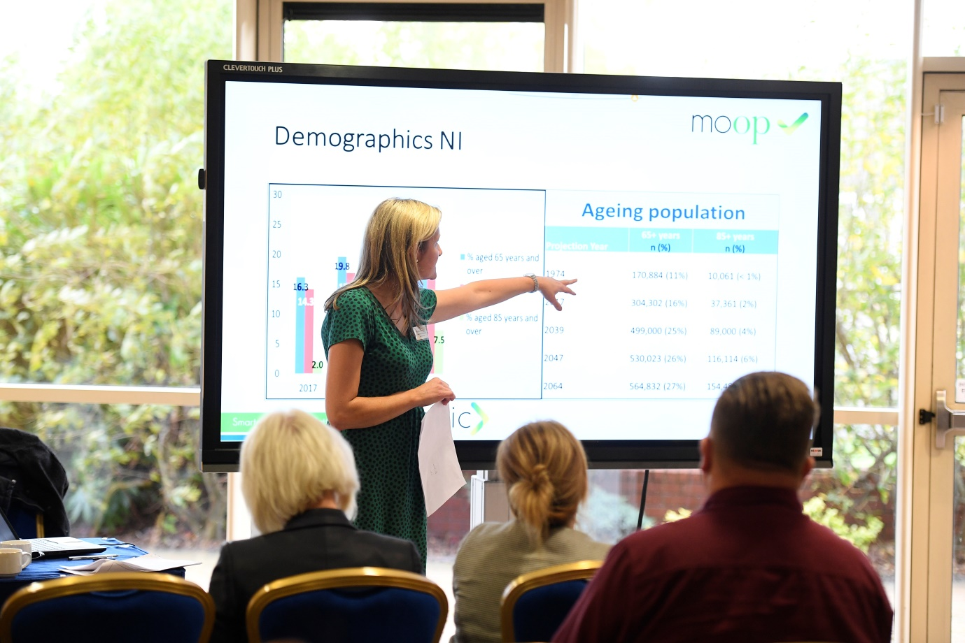
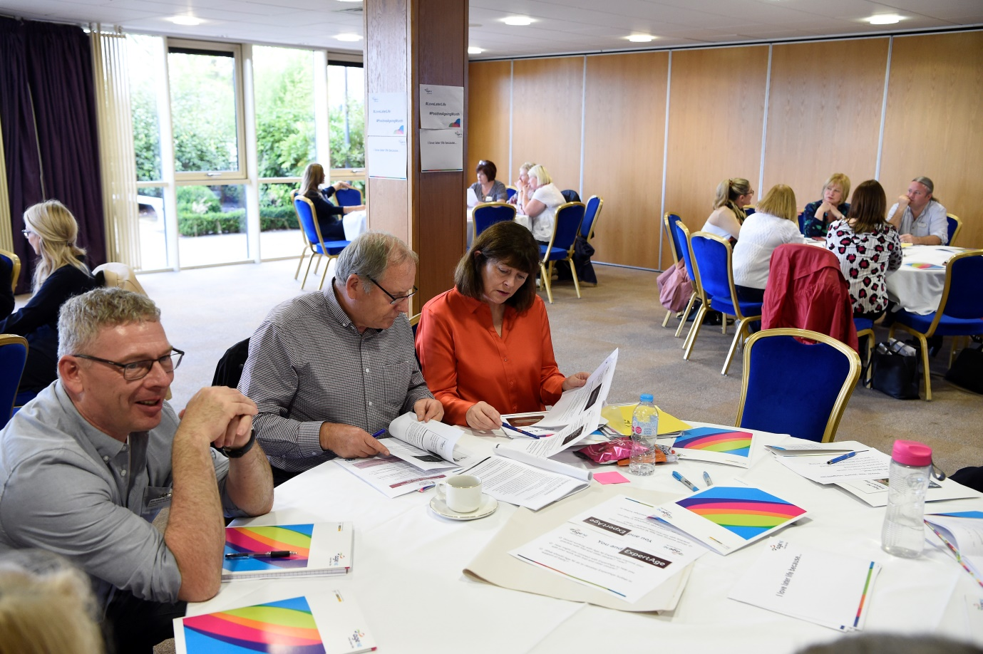

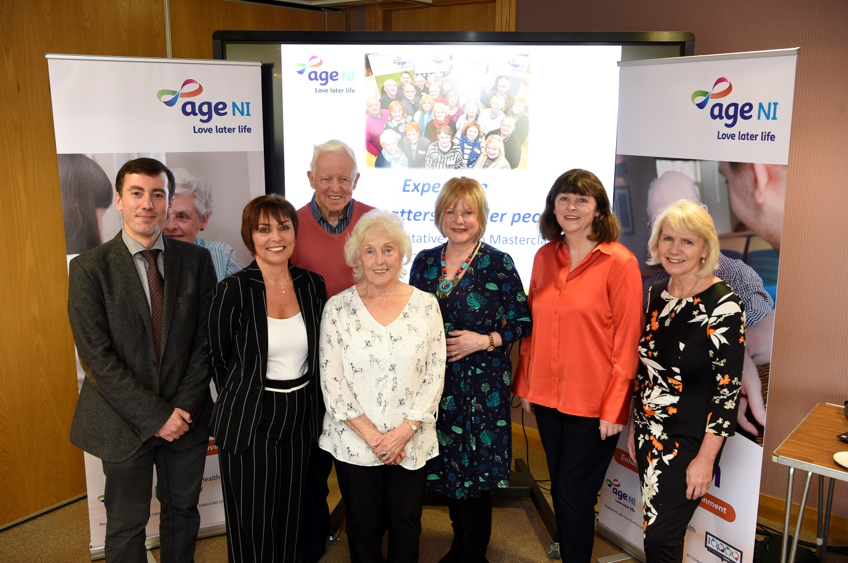
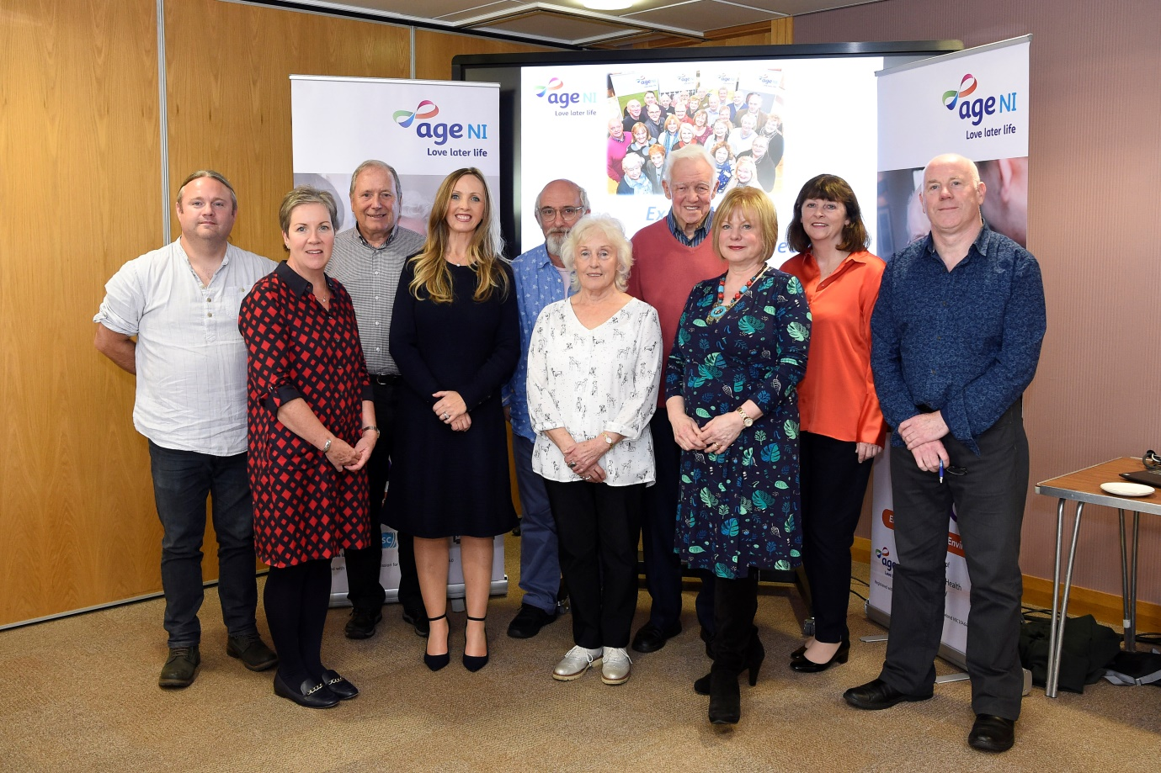
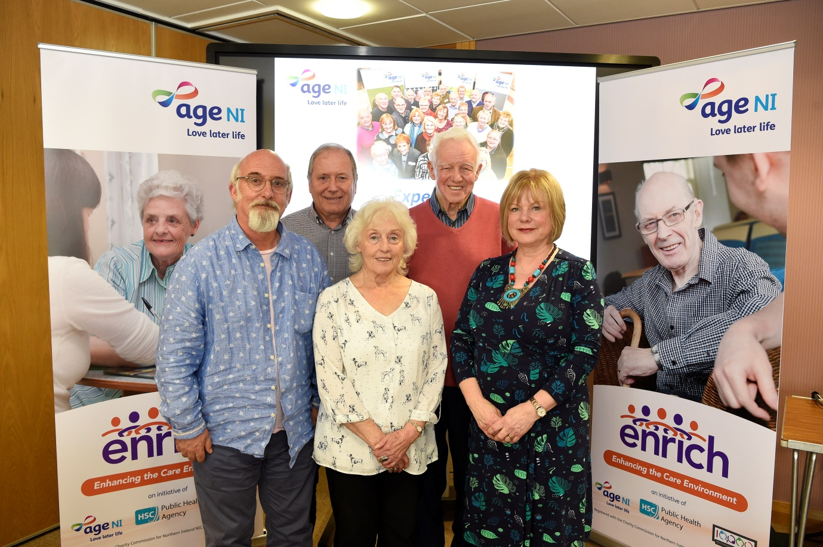
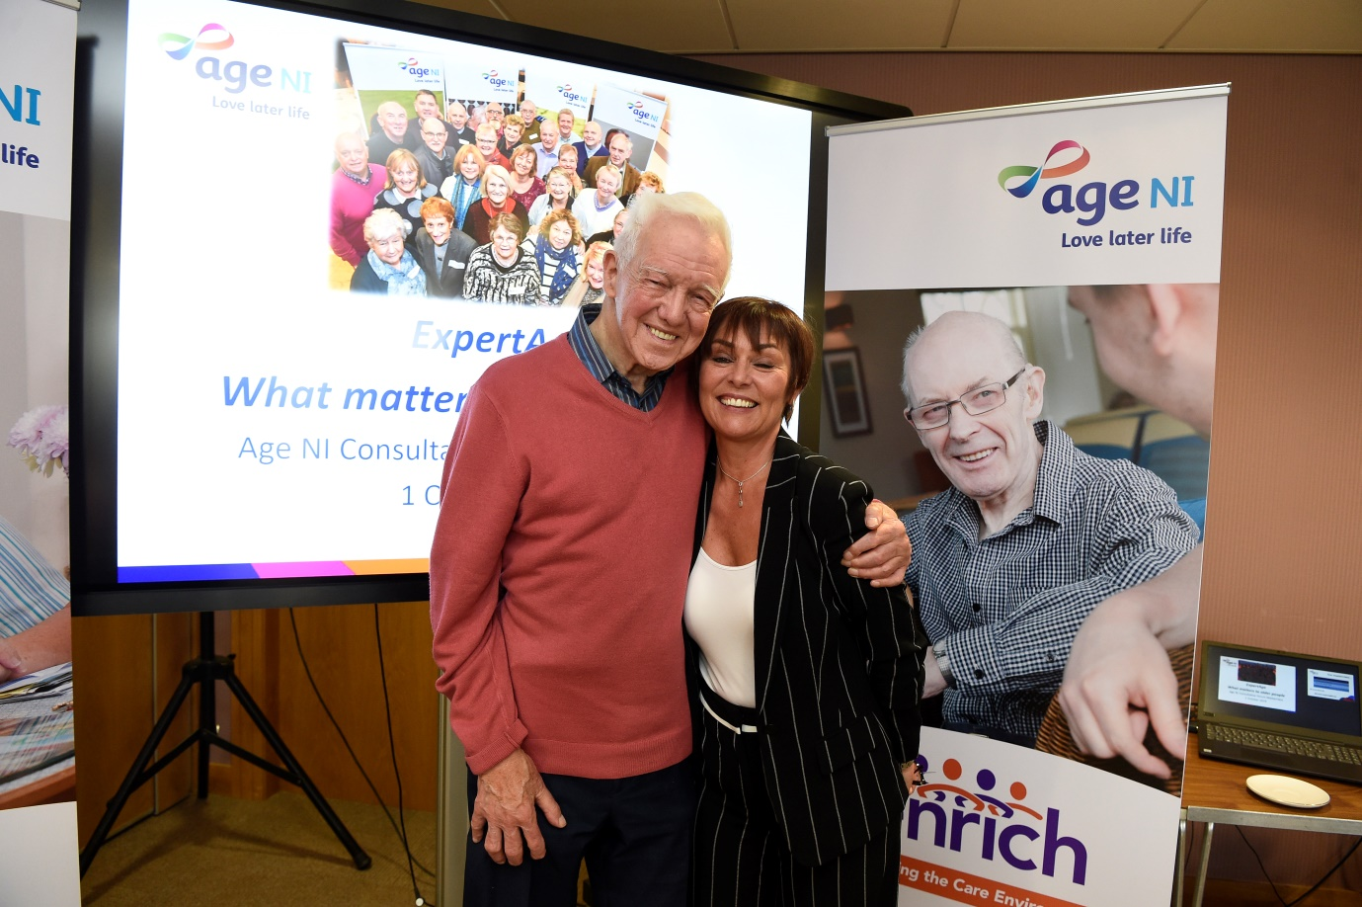

Summary
Overall the day was a success with the majority of attendees having gained something from the experience.
Feedback has shown how we can improve and develop the network and future conferences, workshops and masterclasses.

